Gravitation: MCQs CLASS 09 - PHYSICS
1 | An object floats in water such that$\frac{1}{4}th$ its volume is above the surface of water. When the same object is made to float in a sample of impure alcohol, that volume that remains outside the liquid is $\frac{1}{10}$ total volume. The relative density of the sample of alcohol will be  a) 8.3  b) 0.083  c) 83  d) 0.83 | [1]
2 | The force of attraction between two unit point masses separated by a unit distance is called  a) Gravitational potential  b) Universal gravitational constant  c) Gravitational field  d) Acceleration due to gravity | [1]
3 | Which of the following is the evidence to show that there must be a force acting on the earth and directed towards the sun  a) deviation of falling bodies towards the east  b) apparent motion of sun around the earth  c) revolution of the earth around the sun  d) phenomenon of day and night | [1]
4 | A stone is dropped from the top of the tower. Its speed after it has fallen 20 m is (Take g = 10ms$​^{-1}$ )  a) 30 ms$​^{-1}$  b) 20 ms$​^{-1}$  c) - 10 ms$​^{-1}$  d) 10 ms$​^{-1}$ | [1]
5 | Upthrust depends on:  a) dipped volume of the body immersed  b) density of the liquid  c) volume of the liquid  d) both density of the liquid and dipped volume of the body immersed. | [1]
6 | School bags have a broader base to reduce  a) weight  b) pressure  c) air resistance  d) normal reaction | [1]
7 | A force acting perpendicular on an object is called as ________.  a) thrust  b) gravitational force  c) force only  d) work done | [1]
8 | Suppose, the acceleration due to gravity at the Earth’s surface is 10 m s$​^{-2}$ and at the surface of Mars is 4 m s $​^{-2}$ . A 60 kg passenger goes from the Earth to the Mars in a spaceship moving with a constant velocity. Neglect all other objects in the sky. Which part of figure best represents the weight (net gravitational force) of the passenger as a function of time? 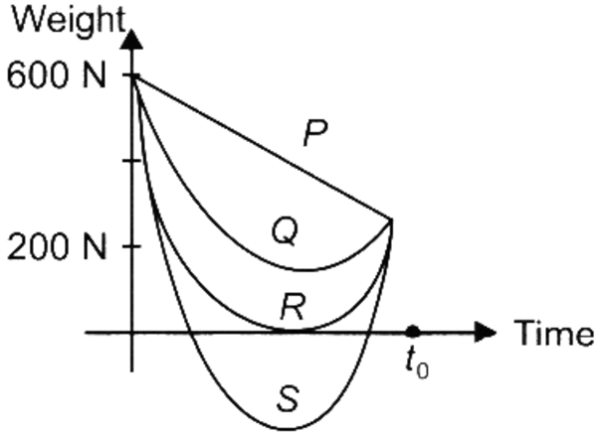  a) S  b) R  c) P  d) Q | [1]
9 | A stone dropped from a certain height takes 4 second to reach the ground. The height is  a) 19.6 m  b) 39.2 m  c) 78.4 m  d) 156.8 m | [1]
10 | Match the column I with column II and select the correct option from the given codes. 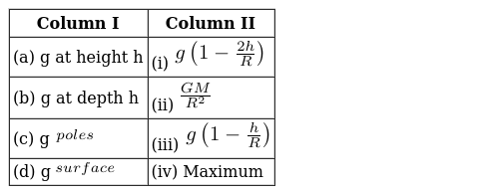  a) (a) - (ii), (b) - (iii), (c) - (iv), (d) - (i)  b) (a) - (ii), (b) - (iv), (c) - (i), (d) - (iii)  c) (a) - (i), (b) - (iii), (c) - (iv), (d) - (ii)  d) (a) - (i), (b) - (ii), (c) - (iii), (d) - (iv) | [1]
11 | A tank 2 m high is half filled with water and then filled to the top with oil of density 0.60 g/cc. What is the pressure at the bottom of the tank due to these liquids? (Take g = 10 m s$​^{-2}$ )  a) 1.6$×$ 10 $​^{2}$ N m $​^{-2}$  b) 1.6$×$ 10 $​^{4}$ N m $​^{-2}$  c) 0.8$×$ 10 $​^{4}$ N m $​^{-2}$  d) 0.8$×$ 10 $​^{2}$ N m $​^{-2}$ | [1]
12 | Earth goes round the Sun with  a) same velocity  b) varying K.E.  c) same momentum  d) varying velocity | [1]
13 | The weight of an object is  a) Equal on both earth and Moon  b) Lesser on earth and Greater on earth  c) None of these  d) Greater on earth and lesser on Moon | [1]
14 | A given solid is weighted in air using a spring balance. It is then weighed separately by immersing it fully first in vessel containing tap water and then in a vessel containing salt solution. The reading of the spring balance would be:  a) least in water  b) equal in all the three cases  c) least in air  d) least in salt solution | [1]
15 | The amount of heat energy lost by hot body in a given time depend on:  a) all of these  b) the area of its surface  c) the temperature of its surface  d) the nature of the surface | [1]
16 | Priya buys a bag of sugar of weight W at a place on the equator. She takes it to Antarctica. The weight of a sugar bag at Antarctica  a) Remains same as the weight at a place on equator  b) Cannot be said  c) Decreases  d) Increases | [1]
17 | The atmosphere is held to the earth by  a) Wind  b) Clouds  c) Earth’s magnetic field  d) Gravity | [1]
18 | Acceleration due to gravity (due to the shell) at any point inside the shell is  a) zero as long as no other mass is outside the shell.  b) cannot be found  c) zero always  d) zero as long as no other mass is inside. | [1]
19 | The height at which the acceleration due to gravity becomes$\frac{g}{9}$ in terms of R, where g is the acceleration due to gravity on the surface of the Earth is (R is the radius of the Earth)  a) $\frac{R}{2}$  b) $\frac{R}{\sqrt{2}}$  c) 2R  d) $\sqrt{\frac{2}{R}}$ | [1]
20 | Acceleration due to gravity varies with  a) shape of the planet  b) All of these  c) height  d) depth | [1]
21 | The gravitational force between two masses kept at a certain distance is p N. The same two masses are now kept in water and the distance between them is kept same. The gravitational force between these two masses in water is q N. Then  a) p > q  b) p < q  c) p = q  d) None of these | [1]
22 | Acceleration due to gravity is  a) All of these  b) Inversely proportional to square of radius for all points on the surface of the planet.  c) Dependent directly on the radius of the planets under comparison are made of same material.  d) Dependent on mass of the planet for points outside the planet. | [1]
23 | While performing an experiment a solid was immersed fully in water and it was observed that the solid has suffered an apparent loss in its weight. This apparent loss in weight of the solid must be equal to the:  a) weight of water displaced by the solid  b) weight of the solid in water  c) weight of the solid in air  d) weight of water filled in the vessel | [1]
24 | An object weights 10 N in air. When immersed fully in water, it weighs only 8 N. The weight of the liquid displaced by the object will be  a) 12 N  b) 8 N  c) 2 N  d) 10 N | [1]
25 | A body is suspended from a spring balance kept in a satellite. The reading of the spring balance is W$​_{1}$ when the satellite goes in an orbit of radius R and W $​_{2}$ when it goes in an orbit of radius 2R. Which of the following is correct?  a) W$​_{1}$ $≠$ W $​_{2}$  b) W$​_{1}$ > W $​_{2}$  c) W$​_{1}$ < W $​_{2}$  d) W$​_{1}$ = W $​_{2}$ | [1]
26 | Acceleration due to gravity on the surface of the earth is the greatest  a) uniform at all places  b) at equator  c) at poles  d) at 23.6$​^{o}$ latitude | [1]
27 | Which of the following graphs shows an approximate variation of g with height h above the Earth’s surface?  a) 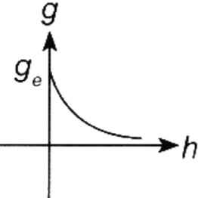  b) 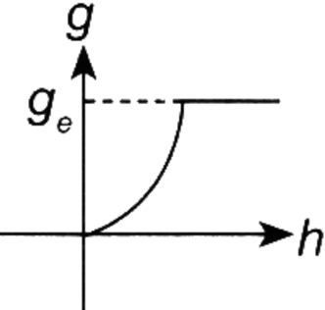  c) 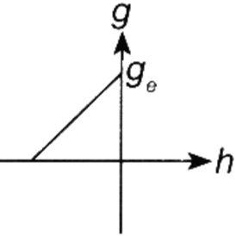  d) 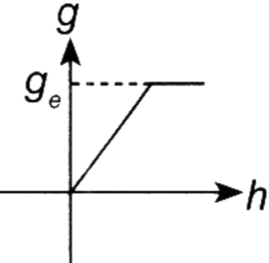 | [1]
28 | Two particles are placed at some distance. If the mass of each of the two particles is doubled, keeping the distance between them unchanged, the value of gravitational force between them will be  a) Unchanged  b) $\frac{1}{4}$ times  c) $\frac{1}{2}$ times  d) 4 times | [1]
29 | The weight of an object at the center of the earth of radius R is  a) $\frac{1}{R^{2}}$ times the weight at surface of the earth  b) Zero  c) Infinite  d) R times the weight at the surface of the earth | [1]
30 | The value of gravitational constant depends upon  a) temperature of the atmosphere  b) masses  c) distance between the masses  d) none of these | [1]
31 | The weight of an object has S.I. unit of:  a) Newton  b) N/kg  c) kg/N  d) kg | [1]
32 | A boy is whirling a stone tied with a string in a horizontal circular path the string breaks, the stone  a) Will continue to move in the circular path  b) Will move along a straight line towards the centre of the circular path  c) Will move along a straight line perpendicular to the circular path away from the boy.  d) Will move along a straight line tangential to the circular path | [1]
33 | A student lowers a body in a liquid filled in a container. He finds that there is a maximum apparent loss in weight of the body when:  a) it is partially immersed and also touches the sides of the container.  b) it is partially immersed in the liquid.  c) it just touches the surface of the liquid.  d) it is completely immersed in the liquid. | [1]
34 | The mass of body is 10 kg at a place where g = 10 m/s$​^{2}$ , its weight is  a) 100 N  b) 1000 N  c) 10 N  d) 1 N | [1]
35 | A heavy cylinder of length 1 is slowly taken out of a dense liquid. The weight felt as it is taken out of the liquid  a) increases till it attains the weight in air  b) decreases as it comes out  c) increases as it comes out  d) will remain the same | [1]
36 | A girl stands on a box having 60 cm length, 40 cm breadth and 20 cm width in three ways. In which of the following cases, pressure exerted by the brick will be  a) Maximum when width and length from the base  b) Maximum when length and breadth from the base  c) Maximum when breadth and width from the base  d) The same in all the above three cases | [1]
37 | When a spaceship is two earth radii distant from the centre of the earth, its gravitational acceleration is  a) 4.9 ms$​^{-2}$  b) 19.6 ms$​^{-2}$  c) 2.45 ms$​^{-2}$  d) 9.8 ms$​^{-2}$ | [1]
38 | The physical quantity in which apparent loss is observed when a solid object is immersed in water.  a) Volume  b) Density  c) Mass  d) Weight | [1]
39 | Variation of acceleration due to gravity g with distance r from the centre of earth with (r > R$​_{e}$ ) is best given as  a) g$∝$ r $​^{2}$  b) g$∝$ r  c) $g∝\frac{1}{r}$  d) $g∝\frac{1}{r^{2}}$ | [1]
40 | There is no atmosphere on moon as  a) it gets light from sun.  b) it is closer to the earth.  c) it revolves round the earth.  d) the gases have less requirement of velocity or energy to escape from its surface. | [1]
41 | A 60 kg man weight W kg on the moon. W is  a) 10 kg  b) 60 kg  c) 5 kg  d) 70 kg | [1]
42 | If the earth stops rotating the value of ’g’ at the equator will  a) none of these  b) remain same  c) decrease  d) increase | [1]
43 | A ball is released from the top of a tower of height h metres. It takes Tseconds to reach the ground. What is the position of ball above the ground in$\frac{T}{5}$ seconds?  a) $\frac{24}{25}h m$  b) $\frac{h}{25} m$  c) 25 hm  d) 24 hm | [1]
44 | Which of the following is not correct?  If we drop a 10 lb iron ball and 1 lb aluminium ball from the top of a high platform inside a mine, then both will reach the floor at the same time.  The gravitational force of attraction between the two bodies increases when their masses are increased and distance is reduced.  We do not observe small objects moving towards each other because frictional force balances the gravitational pull.  When a body is thrown up, the acceleration due to gravity at the topmost point is zero because velocity of the body is zero.  a) Statement (iv) is correct.  b) Statement (iii) is correct.  c) Statement (ii) is correct.  d) Statement (i) is correct. | [1]
45 | The density of tap water is less than that of sea water. If an object is immersed completely in both one by one, its loss in weight will be :  a) Zero in sea water but not so in tap water.  b) More in sea water.  c) Equal in the two cases.  d) Less in sea water. | [1]
46 | If the volume of a body is V and half of it is immersed in the liquid, the upthrust will be proportional to:  a) Difference in density of the body and half the density of the liquid.  b) Half the volume  c) Volume  d) Double the volume | [1]
47 | Law of gravitation gives the gravitational force between  a) Any two bodies having some mass  b) Two charged bodies only  c) The earth and Sun only  d) The earth and a point mass only | [1]
48 | An apple and a stone dropped from certain height accelerates  a) depending on density  b) depends on the position of the SUN  c) equally  d) differently | [1]
49 | If we want to determine the volume of a solid by immersing it in water, the solid should be  a) heavier than water and insoluble in it  b) lighter than water  c) heavier than water  d) insoluble in water | [1]
50 | The ratio of weight to mass of the body is ________.  a) zero  b) 9.8  c) 1.0  d) 10 | [1]
51 | The upward force experienced by abody when submerged in a fluid is called  a) Buoyant force  b) Muscular force  c) Liquid force  d) Frictional force | [1]
52 | The weight of a body felt in tap water and salty water are W$​_{A}$ and W $​_{B}$ respectively, then :  a) W$​_{A}$ = W $​_{B}$  b) W$​_{A}$ > W $​_{B}$  c) W$​_{A}$ < W $​_{B}$  d) W$​_{B}$ = 2W $​_{A}$ | [1]
53 | In a tank having ’h’ height of liquid, two points at a depth$\frac{3h}{4}$ from free surface have pressure P $​_{A}$ and P $​_{B}$ . When point A is closer to the wall than B. Then  a) P$​_{A}$ > P $​_{B}$  b) P$​_{A}$ < P $​_{B}$  c) P$​_{A}$ = P $​_{B}$  d) Depends on density | [1]
54 | If a planet existed whose mass was twice that of Earth and whose radius 3 times greater, how much will a 1 kg mass weigh on the planet?  a) 1.1 N  b) 25 N  c) 2.17 N  d) 5 N | [1]
55 | If cross - sectional area of an object is more than the pressure applied by the external force is : -  a) Less  b) More  c) None of the above.  d) Remains same | [1]
56 | A heavier and a lighter body have equal momentum, then  a) heavier will have more K.E.  b) lighter will have more K.E.  c) they will have equal K.E.  d) K.E. will be independent of momentum | [1]
57 | The value of quantity G in the law of gravitation  a) Is independent of mass and radius of the earth  b) Depends on both mass and radius of the earth  c) Depends on mass of the earth only  d) Depends on radius of the earth only | [1]
58 | The least value of apparent weight of a body in a fluid is  a) = 0  b) depends on the density of solid and fluid  c) < 0  d) > 0 | [1]
59 | Two objects of different masses falling freely near the surface of the moon would  a) Have different acceleration  b) Have same velocities at any instant  c) Undergo a change in their inertia  d) Experience forces of same magnitude | [1]
60 | Increase in momentum by 20% will increase the K.E. by  a) 10%  b) 20%  c) 40%  d) 44% | [1]
61 | A mass weighing W can float if the upthrust U is related as  a) U > W  b) $∪≥W$  c) U = W  d) U < W | [1]
62 | A ball is thrown vertically upward, acceleration due to gravity is  a) In the direction same as the direction motion.  b) In the direction opposite to the direction of motion.  c) Increases as it comes down.  d) Becomes zero at the highest point. | [1]
63 | In the relation F =$\frac{Gmm}{d^{2}}$ , the quantity G  a) Is greater at the surface of the earth  b) Depends on the value of g at the place of observation  c) Is universal constant of nature  d) Is used only when the earth is one of the two masses | [1]
64 | Acceleration due to gravity on the surface of the moon is$\frac{1}{6}$ th of its value on the surface of the earth as they have different  a) radius  b) All of these  c) density  d) mass | [1]
65 | Two bodies, one held 1 m vertically above the other, are released simultaneously and fall freely under gravity. After 2 second, the relative separation of the bodies will be  a) 4.9 m  b) 19.6 m  c) 9.8 m  d) 1 m | [1]
66 | If the weight of an object in air and a dense liquid are W$​_{a}$ and W $​_{l}$ respectively, then upthrust  a) U = W$​_{l}$ + W $​_{a}$  b) U = 2W$​_{l}$  c) U = W$​_{a}$ - W $​_{l}$  d) U = W$​_{l}$ - W $​_{a}$ | [1]
67 | A coil of wire with cross - sectional area 0.50 mm$​^{2}$ weighs 75N in air and 65N in water. The length of the coil in cm is (Take g = 10 m/s $​^{2}$ )  a) $\frac{{10}^{2}}{0.50}$  b) $\frac{{10}^{6}}{5}$  c) $\frac{{10}^{5}}{0.0050}$  d) $\frac{{10}^{2}}{50}$ | [1]
68 | Any object having sufficient positive energy can escape from the gravitational pull of the earth as  a) K.E. will be more to escape the gravitational potential energy  b) K.E. is negative otherwise  c) Negative energy means it is bound  d) P.E. is positive for total energy being positive | [1]
69 | Even though stone also attracts earth towards itself, the earth does not move:  a) Force exerted by stone is less  b) Because of lesser mass of stone  c) Because of greater mass of earth  d) Force exerted earth is large | [1]
70 | A wooden block is floating in water contained in a beaker. During the free fall of the beaker, the upthrust on the block will be  a) Slightly less than the weight of the block.  b) Equal to the weight of the block  c) Zero  d) Slightly more than the weight of the block. | [1]
71 | In a spring balance the space between 0 and 25 g marks is divided into 10 equal parts. The least count of spring balance is:  a) 15 g wt  b) 2.5 g wt  c) 25 g wt  d) 0.25 g wt | [1]
72 | The value of acceleration due to gravity  a) Increases from pole to equator  b) Is least on equator  c) Is same on equator and poles  d) Is least on poles | [1]
73 | A body at rest having uniform acceleration is  a) possible only near the sun.  b) any body thrown vertically up against gravity.  c) can be released only on the moon.  d) non - existing | [1]
74 | Statement 1 : The weight of the body becomes zero at the centre of the earth. Statement 2 : As the distance from centre of earth decreases, acceleration due to gravity also decreases.  a) Both statement 1 and statement 2 are true but statement 2 is not the correct explanation of statement 1.  b) Both statement 1 and statement 2 are true and statement 2 is the correct explanation of statement 1.  c) Both statement 1 and statement 2 are false.  d) Statement 1 is true but statement 2 is false | [1]
75 | Statement 1 : A pendulum can vibrate in an artificial satellite. Statement 2 : Inside the satellite, acceleration due to gravity is zero.  a) Statement 1 is true but statement 2 is false.  b) Statement 1 is false but statement 2 is true.  c) Both statements 1 and 2 are true and statement 2 is the correct explanation of statement 1.  d) Both statements 1 and 2 are true but statement 2 is not the correct explanation of statement 1. | [1]

